Year 2 End of Summer 1
We have had such a great term. The children have been so busy that I am sure they need a well-deserved rest over half term.

Bug hotels
We have been very impressed with all the of the bug hotels that the children have created at home. Thank you for sharing these on Purple Mash.
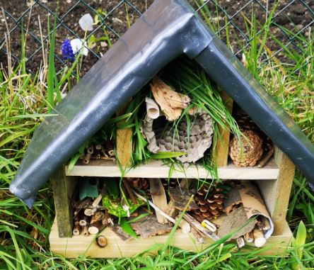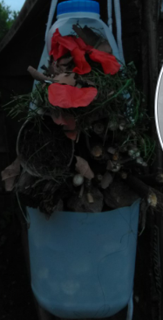

Dragon post
The children have absolutely loved our class book ‘Dragon Post’ and have produced amazing writing based on the story. Well done Year 2.

Maths
The children have been learning about money and making different amounts. You may like to play some games at home using money or set up a shop.

#

Next Term Summer 2
We are really looking forward to next term. We have got amazing things planned.
This term we have been learning about the United Kingdom and England. Next term, we will be looking at another Country. I wonder if you can guess which Country by the following clues:
1 – It has one of the best national teams in cricket.
2- It has a very famous white marble building.
3- The money in this country is called Rupee.

Can you guess?

Have a lovely half term everybody and see you next term.
Mrs Price and Miss Allen

