Hello!
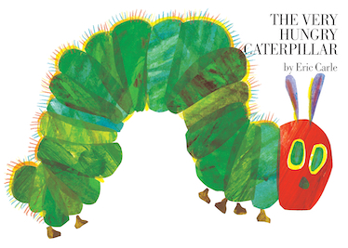
We hope you have all had a fabulous half term. We are in the final term of the year and what fun we have planned! We are excited to begin our topic “The Very Hungry Caterpillar”

We will be having some real caterpillars come to visit us and we will be able to watch them grow, as well as this we are going to be making some yummy pizza and trying lots of new foods.
We will be beginning our transition period with the children to help prepare them for their new learning journeys in September.
The pre-school children will continue their preparation for school, we will be practicing our self-help skills and learning how to do simple tasks independently, we will be practicing writing our names and forming letters correctly. As well as this we will continue to practice following simple instructions and begin to play cooperatively together.

As the weather begins to change please ensure your children are wearing weather appropriate clothing. The children should have a sun hat and sun cream should have been applied before they come to nursery each day, when the weather is warm.

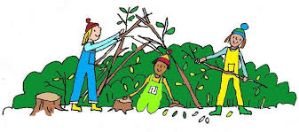
Rabbit’s Class will be taking part in forest school this term. Forest School will take place on: Wednesday afternoons.

For forest school you will need;
• Wellington boots/old trainers
• weather appropriate clothing
Please bring a change of clothes and shoes too, just in case the children get wet whilst outside.
Things to remember:
Grown up’s need to wear a face mask when they are dropping off or collecting from Nursery
Only one person from each house hold should be coming to collect or drop off each child.
We will be doing lots of handwashing throughout the session, including when you arrive and leave nursery.
Please do not bring in any toys from home, as we are ensuring all items in nursery are cleaned throughout the day.
Thank you all so much for your continued cooperation, we hope you have all managed to have a restful break and are ready to begin our final term of the year.

Miss Long and the nursery team.
