Term 6 in Year 4
Hello Year 4,

After five terms of hard work and a period of remote learning, we are ready for our final term in year 4. It has been a fantastic year so far despite the challenges we have experienced with remote learning and new procedures. Let’s make sure our final term is the best one yet!
Daily timetable:
We have had a slight change in our weekly timetable. Most notably, PE on a Thursday has been moved to Tuesday which means our class will enjoy a double PE session on Tuesday afternoons. Therefore, children only need to arrive at school in PE clothes on a Tuesday.
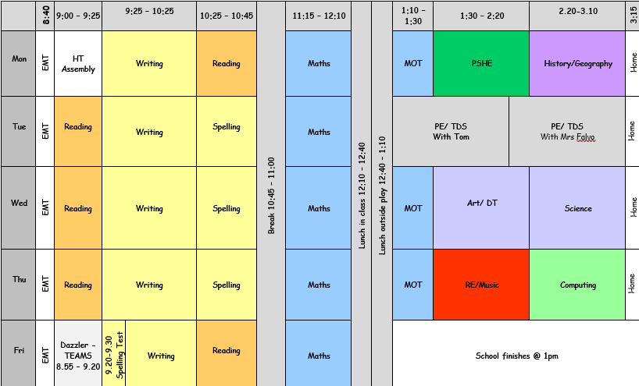
DT:
In DT, we have started creating an erupting volcano in groups. These will be completed in term 4. The children are looking forward to decorating them so that they look realistic for when we finally erupt them.
Break Time
Although children will always be allowed to use the toilet during lessons, it is imperative that children do not miss out on important learning. Therefore, we encourage children to utilise the toilets during their breaks and lunch times. Although we are no longer taking part in the healthy eating competition, we would still like to encourage children to eat healthy snacks during break time.

Homework:
In term 6, we will continue to have weekly spellings which will be followed up by a Friday spelling test. Further to this, children will receive maths homework that relates to the learning they experienced that week. We would encourage children to return their completed homework so they benefit from extra practice and we can assess their understanding of the topic. Children will continue to receive dojo points for their efforts.

Mr Pryce

