Midnight Garden Newsletter
Previous Learning:
This week, we have finished our Roman shields and in groups, considered how Romans may have used them to become one of the most effective armies ever.
Children worked in groups to create their own defensive tactic to keep all their soldiers safe before attempting the Roman testudo (tortoise) formation.
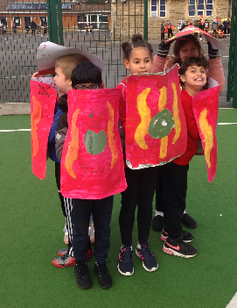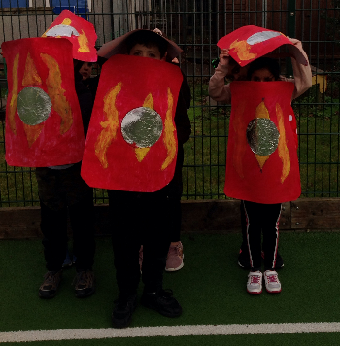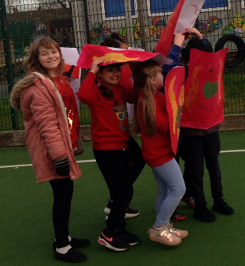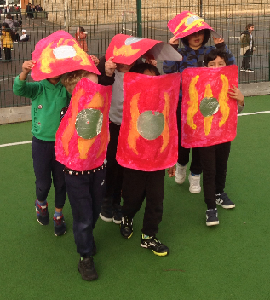
If you were lucky, you may have seen the children leaving school in their testudo formations on Thursday 17th December.

Although we haven’t finished, we have made Roman aqueducts, using cardboard, tin foil and creating cardboard flaps to join the parts together. We are yet to paint them a sandstone colour and test to see if they can be used to transport water.
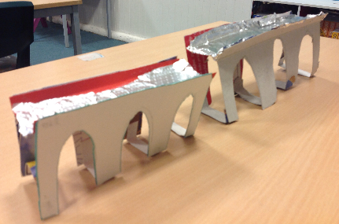
This week we also created 3D snowflakes which can be very fiddly and requires a lot of patience. Here they are lined up at the back of our classroom on display.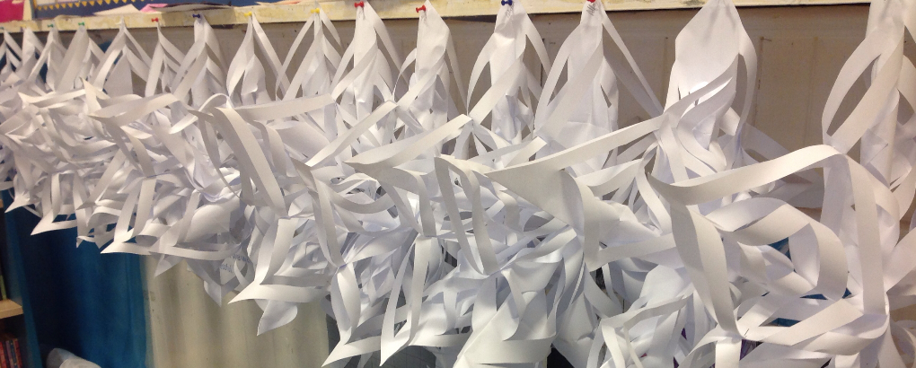
Reading:
Well done to the following children who have been reading an exceptional amount at home and are top of the table for changing their reading books:
Oskar
Mehmet
Maya
Leonel
Nadine
Logan
Christmas:
Thank you children and parents for all the hard work and co-operation during these first two terms. I hope you have a fantastic Christmas and New Year.

Stay safe,

Mr Pryce

