After School Clubs

- Football for Y’s 1&2  TUESDAYS - Until 4.15pm  Log onto ParentPay to book your space!  Maximum 25 spaces |  |  | - Football for Y’s 3&4  WEDNESDAYS – Until 4.15pm  Log onto ParentPay to book your space!  Maximum 25 spaces |  | - Football for Y’s 5&6  THURSDAYS - Until 4.15pm  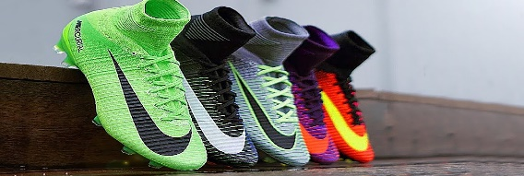  Log onto ParentPay to book your space!  Maximum 25 spaces
All Clubs are free!  And finish at 4.15pm. |  |  | Basketball for Y’s 1&2  WEDNESDAYS - Until 4.15pm  Log onto ParentPay to book your space!  Maximum 25 spaces |  | After School Clubs will START from W/C 10th January and FINISH on W/E 8th April 2022.
Hockey for Y’s 5&6  TUESDAYs – Until 4.15pm  Log onto ParentPay to book your space!  Maximum 25 spaces |  |  | Please log onto ParentPay and book a space for your child before the closing date:  17/12/21 |  | Multi-Sports for Y’s 3&4  THURSDAYS - Until 4.15pm  Log onto ParentPay to book your space!  Maximum 25 spaces

