FRENCH:
YEAR 5
KNOWLEDGE ORGANISER
Greetings and Basic Questions/ Answers |  |  | Colours
Bonjour - Hello Bonsoir – Good evening/ Good night Excusez-moi – Excuse me Comment tu t’appelle? – What’s your name? Je m’appelle… – My name is…  Ça va? – How are you? (informal) Ça va bien – I’m doing well Ça va mal – I’m not doing well Comme ci, comme ça – so, so Au revoir - Goodbye Salut – Bye Bonne journée – Have a nice day  Oui - Yes Non – No S’il vous plaît – Please Merci – Thank you |  |  | COULEURS  (colours) |  | bleu(e) – blue  noir(e) – black  vert(e) – green  violet(te) – violet | gris(e) – grey  blanc(he) – white  jaune - yellow | rouge – red  orange – orange  marron - brown
Days of the Week
L’ALPHABET ( THE ALPHABET) JOURNÉES (DAYS) lundi - Monday mardi - Tuesday mercredi - Wednesday jeudi - Thursday vendredi - Friday samedi - Saturday dimanche - Sunday  A - ah avion - plane  B - bay ballon - balloon  C - say citron - lemon  D - day dauphin - dolphin  E - er escargot – snail  F - eff fraise - strawberry  G - shay gateau - cake  H - ash hibou - owl  I - ee ile - island  J - shee jardin - garden  K - car kangourou - kangaroo  L - ell livre - book  M - emm mouton - sheep  N - enn nuage - cloud  O - oh ordinateur - computer  P - pay poisson - fish  Q - coo quille - skittle  R - air raisins - grapes  S - ess soleil - sun  T - tay tortue - tortoise  U - ooo un - one  V - vay vache - cow  W – doubla-vay wagon – truck/carriage  X - ix xylophone - xylophone  Y – ee-grek yacht - yacht Mon anniversaire est en… My birthday is in…  Z - zed zèbre - zebra |  |  | 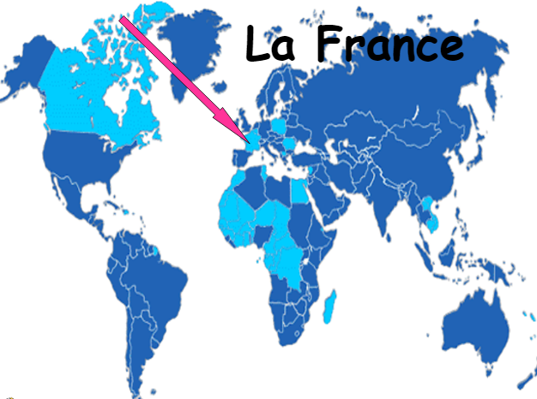 |  |  | 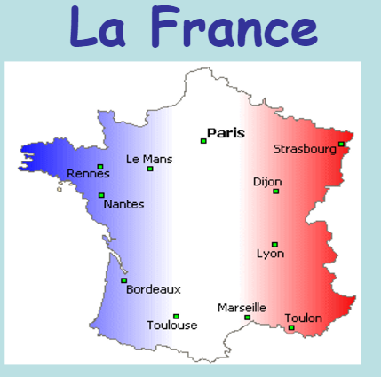

0 1 2 3 4 5 6 7 8 9 10 11 12
zero un deux trois quatre cinq six sept huit neuf dix onze douze
Number Line

