**English**

We will be using the beautiful picture book “Ocean meets Sky” by the Fan Brothers as our inspiration for learning in English this term. This stunning picture book is about a young boy who sets sail to find a place his grandfather told him about... the spot where the ocean meets the sky. It is an engaging story of remembrance.

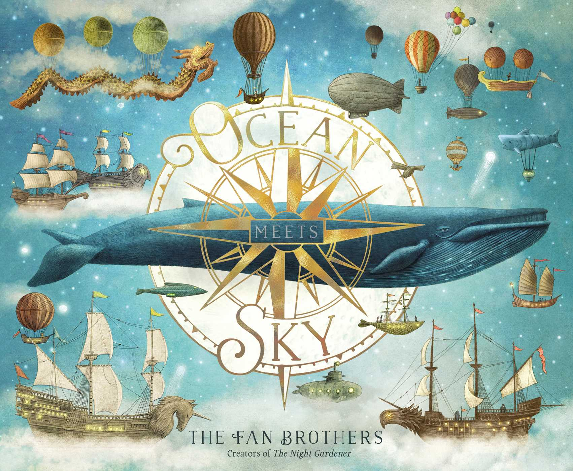

The children will continue to develop their reading and writing skills by becoming story tellers. We will be using these to create both fiction and non-fiction pieces of writing. The class will learn through drama, story rehearsal and through reading activities which will develop their language. Alongside this, the children will be focusing on adjectives, spellings, noun phrases and story structure.

**Mathematics**

We will be focusing on addition and subtraction. This will include adding and subtracting 2-digit numbers, rounding to compensate and using known number facts to add and subtract mentally. The children will move from using practical resources to pictorial representations. Then they will use a written method to show working out through number lines and partitioning. The children will continue to work with clear differentiation and challenge for all using the do it, secure it and deepen it mastery approach. This will involve problem solving and reasoning with the use of maths equipment and word problems.

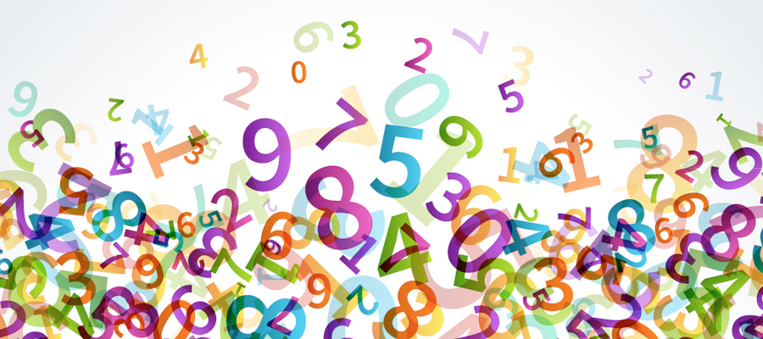

Our afternoon slot will involve daily fluency where the children will practise key maths objectives in the form of games and becoming speedy with mental maths.

**Art and Design**

In Art and Design this term we will kickstarting our new Big Question by creating our very own class canvas to be displayed in our reading area – linked to our key text we are using in English. We will be learning all about printing and applying this to our canvas masterpiece!

We will finish off the term by doing Some Design Technology where we will be designing and making our own boats! Here we will be looking at the features that go into a boat and applying these when we make them!

**Computing**

To start off this term in Computing, we will be refreshing ourselves with the SMART rules and the importance of staying safe online. We will then be moving onto Multimedia where we will be learning to use Purple Mash apps to create pieces of art and story-telling.

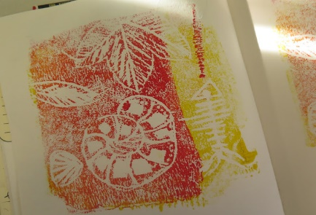

**Science**

This term we will be immersing ourselves in a mix of scientific topics linked to other areas of the curriculum. We will be investigating materials that float to help us with our Design Technology, looking at sea animals and birds for our English and investigating how different weather will affect both our boats and the sea creatures.

Through these topics, the children will be working scientifically though performing tests, asking and answering questions, identifying and classifying and gathering and recording data. They will question what they see and make careful observations and recordings which will help them make sense of the world in which they live.

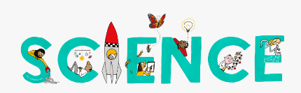

**Physical Education, PSHE & Well Being & Music**

Our P.E. days will be **Tuesday and Thursday**. Children need to come to school wearing their kit. PE will be outside as much as possible so please ensure children have a jumper to wear. On a Tuesday is outdoor PE where the children will be learning hockey. On a Thursday is gymnastics where the children will be focusing on **Stability** where the children will be practising their balancing, jumping, and landing. Basic yoga will also be incorporated.

Our JIGSAW topic will be ‘Celebrating Difference’. During this time children will explore differences between one another and be able to say why they value this about them.

During Music the children will be looking at a variety of ways to make rhythms and music. We will focus on classical music and a virtual workshop with the BBC philharmonic orchestra.

**‘What’s inside your imagination?’**

**‘Imagination Station’**

**Kingfisher Class**

Autumn 2 2020

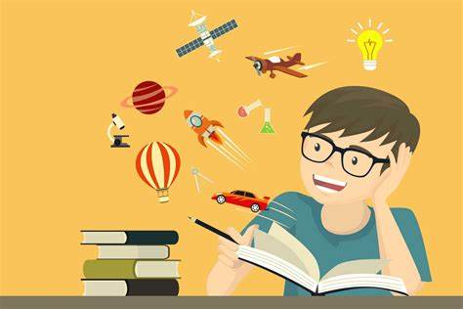

Mrs Evans and Miss Bond

**Geography & RE**

In Geography this term we will be using our key text ‘Ocean meets Sky’ to think about where in the world we might find this ocean. We will be exploring the 7 continents and the 5 oceans before beginning to think about the 4 characteristics of the countries and capital cities of the United Kingdom. We will be using globes and maps to help us locate them.

In RE this term we will be looking at Light and Dark. Here we will be understanding about different festivals of light from around the world. We will also look at why it is important to respect everybody’s ideas and beliefs, linking to our Jigsaw topic.