Year 6 Autumn 2 Newsletter

Dear Parents and Carers,

Welcome back to term 2, we hope that you are all keeping well. This term we will be learning all about World War 2 in topic and will be reading Rose Blanche by Roberto Innocenti and Ian McEwan.

PE

This year our PE session is on a Monday. All children must arrive to school in their uniform.

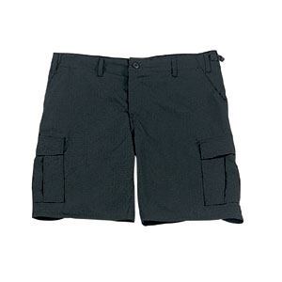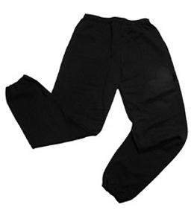Their kit should consist of a white t-shirt, dark blue or black shorts/jogging bottoms, jumper and trainers/daps.

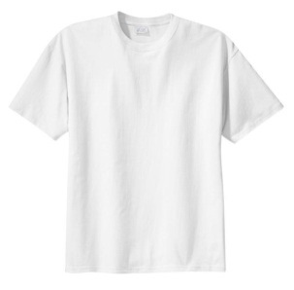

**No jewellery is to be worn; hair needs to be tied back and head scarves must be short and tight fitting.** These are to ensure the safety of your child.

READING

Every child will have their own individual log in for Rising Stars Reading Planet to access books set by the class teacher. To access the Reading Planet, search for ‘my rising stars’ on Google. Then enter the user name and password which has not changed from previous years.

It is also important that you listen to your child read books as much as possible, as this will help both their reading and writing abilities.

HOMEWORK

Your child will receive homework each week. This homework will be set online on a **Friday** and should be completed by the following **Wednesday**. Each week, your child will be set one spelling task, one maths task and a reading book will be set on Reading Planet (online).

SATs Revision

At the end of Year 6 your child will complete SATs assessments. To further accelerate their attainment, we would like your child to begin to revise using the revision book provided.

If you have any questions, please do not hesitate to contact the school office.

Many Thanks

Mr Roberts, Mrs Waller and Mrs Vernon

The Year 6 Team