Year 6 Autumn 1 Newsletter

Dear Parents and Carers,

Welcome back to the new school year. We hope that you are all keeping well. This year will be the most important year at Drove for your child. We will ensure that your child is prepared for secondary school.

PE

This year our PE session is on a Monday. All children must arrive to school in their uniform.

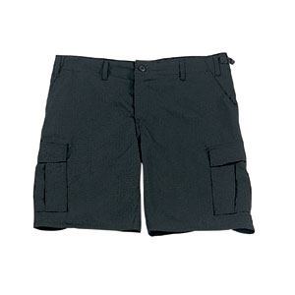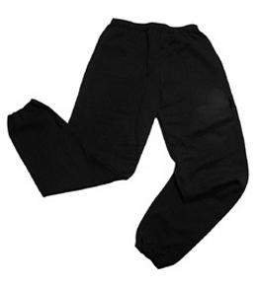Their kit should consist of a white t-shirt, dark blue or black shorts/jogging bottoms, jumper and trainers/daps.



**No jewellery is to be worn; hair needs to be tied back and head scarves must be short and tight fitting.** These are all to ensure the safety of your child.

READING

Every child will have their own individual log in for Rising Stars Reading Planet to access books set by the class teacher.

It is also important that you listen to your child read books as much as possible, as this will help both their reading and writing abilities. This year, your child will also be given the opportunity to take a reading book home from class.

Reading comprehension is a important skill. You will need to support by asking your child questions about their book after they have read - such as ‘How do you know he is angry?’ or ‘Why is she happy?’

HOMEWORK

Your child will receive homework each week. This homework will be set online on a **Friday** and should be completed by the following **Wednesday**. Each week, your child will be set one spelling task, one maths task and a reading book will be set on Reading Planet (online).

If you have any questions, please do not hesitate to contact the school office.

Many Thanks

Mr Roberts, Mrs Waller and Mrs Vernon

The Year 6 Team