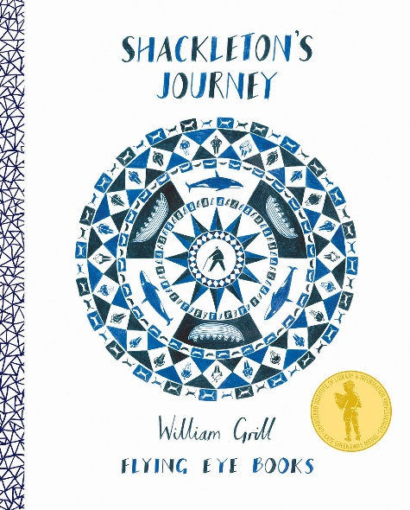Year 6 Term 4

Dear Parents and Carers,

We hope you and your children have had a restful half-term and are now ready to start term 4 revitalised and ready to get back to school!

|  |  |
| --- | --- |
| Literacy | In English, we will be using the book ‘Shackleton’s Journey’ by William Grill (a non-fiction text about the journey of Ernest Shackleton and his crew to the Antarctic) to support our reading and writing sessions. Our final outcome will be to write a persuasive leaflet and a diary entry in character. To do this we will be sharing high quality examples of reports, leaflets and diaries to understand the structure of the writing as well as learning to write for different purpose and audiences. |
| Reading comprehension | In our reading comprehension lessons will be looking at Shackleton’s Journey in more detail and other related texts, including, fiction texts. We will continue practising a variety of reading comprehension skills using these texts, including, inference, deduction and vocabulary-based questions. |
| Numeracy | We will continue to practise our arithmetic methods at the start of each lesson.  This term we be revising our understanding of ratio, proportion, measure and algebra. We will have a secure method for all of the operations and be able to apply these methods within problem solving situations. |
| Science | We are going to continue to investigate evolution and inheritance. We will discover how humans evolved using scientific evidence. We will use scientific skills such as, describing evidence for a scientific area, selecting and using information effectively to explain how the interpretation leads to new ideas. |
| PE | In PE, this term, we will be focused on developing attacking and defending skills through team games such as, basketball, netball or hockey when we are back at school. Our online lessons will be focussed on keeping fit and active through ‘PE with Joe’ routines. |
| Geography | Geography this term will be focussed on mapping skills, we will be proactively implementing our metacognition skills to use different types of maps. This involves understanding symbols, scaling, using compasses, understanding grid references and locating difference countries. We will eventually be planning our own journey! |

Additional Information

PE

When we are back at school, please note that your child will need to have the correct PE kit in school **every day.**

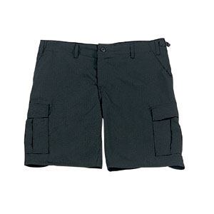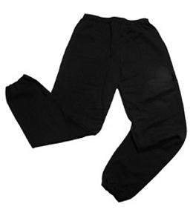Their kit should consist of a white t-shirt, dark blue or black shorts/jogging bottoms and trainers/daps.

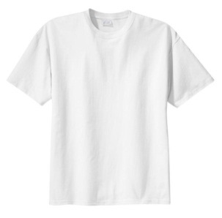

**No jewellery is to be worn; hair needs to be tied back and head scarves must be short and tight fitting.** These are all to ensure the safety of your child.

Purple Mash

Whilst online learning continues, please ensure your children are using Purple Mash to communicate with their teachers daily and are sending any work required throughout the day – this will be directed by the teacher. If your child has any problems logging in or has forgotten their password, please let the office/teacher know as soon as possible.

HOMEWORK

Homework continues to be set on a Friday through reading eggs and should be completed by the following Thursday. Every child is set 1 reading comprehension task and 1 spelling task per week. Both must be completed. Additionally, children should aim to read at home every day; either, through their own books or the vast online library of books on reading eggs. If your child has any problems logging in or has forgotten their password, please let the office/ teacher know as soon as possible.

Many Thanks,

The Year Six Team