Year 4 Summer Newsletter

Dear Parents and Carers,

Welcome back to term 6. We hope that you enjoyed the half term break.

PE

This year our PE session is on a Wednesday. Due to Covid 19, all children must arrive at school wearing their PE kit.

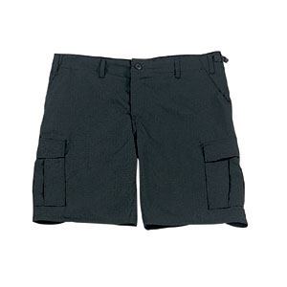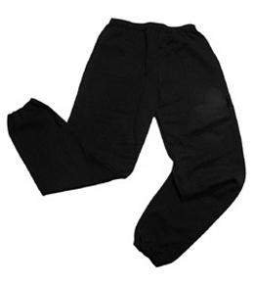Their kit should consist of a white t-shirt, dark blue or black shorts/jogging bottoms, jumper and trainers. Due to the summer weather, ensure your child has sun cream, sun hat and a water bottle.

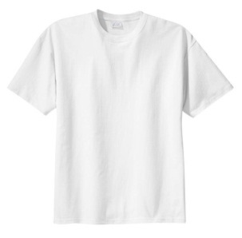

**No jewellery is to be worn; hair needs to be tied back and head scarves must be short and tight fitting.** These are all to ensure the safety of your child.

Reading Homework

Please ensure that your child is using reading eggs to complete their homework each week. Please take the opportunity to support your child whilst they are working on Reading Eggs. Each week, your child will be set one reading comprehension task and one spelling task on Reading Eggspress.

It is also important that you listen to your child read books as much as possible, as this will help both their reading and writing abilities. Reading comprehension is a focus so they will need your support to help practise the skills we will teach. You can help at home by sitting with your child to support them.

Home learning

If a case of Covid-19 is present within our classes, the class bubble affected will be sent home. Whilst at home, teachers will stream live lessons like in previous terms.

If you have any questions, please do not hesitate to contact the school office.

Many Thanks

Mr Roberts, Mrs Walker and Miss Gheorghe

The Year 4 Team