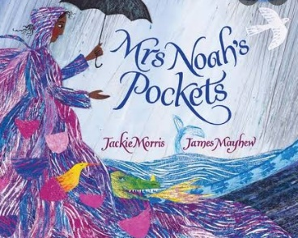 Year 4 Autumn 2

Dear Parents and Carers,

We hope that you’ve had an enjoyable half term and that your children are ready for Term two.

|  |  |
| --- | --- |
| English | In English, this term, we will be studying the book ‘Mrs Noah’s pockets by Jackie Morris and James Mayhew and using the text to support our year 4 writing skills.  We will cover the national curriculum grammar, punctuation and spelling targets such as noun phrases expanded with prepositional phrases, inverted commas to mark speech and complex sentences with the subordinate clause at the start and at the end of the sentence. |
| Reading comprehension | As well as reading every day, it is also extremely important to practise asking and answering questions about the text. Reading comprehension forms a prominent part of the curriculum and we will practise the skills of answering retrieval and inference questions. |
| Maths | In numeracy, we will learn the multiples of 6, 7 and 9 and the division facts related to those times tables.  We will practise the mental addition and subtraction using bridging or rounding and adjusting methods. |
| Science | Science this term covers the topic of Living Things and their Habitats. We will look at the characteristics of a living thing and what living things can do to survive natural changes of the environment.  Children will be encouraged to recognise that changes to an environment can be dangerous to living things. |
| PE | We will be doing Invasion Games such as netball and handball. |
| Music | In music this term, the children will be continuing their singing assemblies. |
| History | This term, our topic will be History and we will be studying Saxons. This includes looking at how the legal system worked in Anglo-Saxon Britain and how the last Anglo-Saxon kings shaped Britain. |
| Art | In art, we will be focussing on Form 3d work. We will be expanding an insect and making 3D insects’ sculptures. |
| RE | In RE, we are going to look at and learn about Hinduism and what is means to be Hindi in Britain today. |
| ICT | In computing lesson, we will be looking at Information technology and online safety including Online Bullying. |

Additional information

PE

This year our PE session is on a Wednesday. Please note that your child will need to have the correct PE kit in school every day.

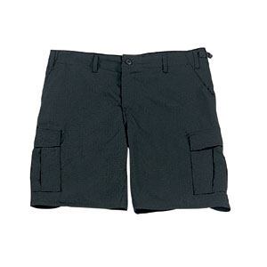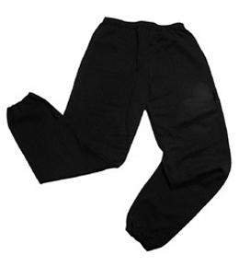Their kit should consist of a white t-shirt, dark blue or black shorts/jogging bottoms, jumper and trainers/daps.

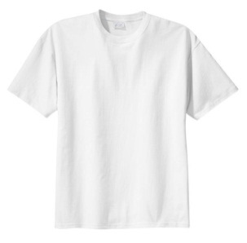

**No jewellery is to be worn; hair needs to be tied back and head scarves must be short and tight fitting.** These are all to ensure the safety of your child.

READING

Every child will have their own individual log in for Rising Stars (<https://www.risingstars-uk.com> ). Please ensure that your child is using Rising Stars to complete their homework each week. Please take the opportunity to support your child whilst they are working on Rising Stars. It is also important that you listen to your child read books as much as possible, as this will help both their reading and writing abilities. Reading comprehension is a big focus so they will need your support to help practise the skills we will teach. You can help at home by asking your child questions about their book after they have read such as ‘How do you know he is angry?’ or ‘Why is she happy?’

HOMEWORK

Your child will receive homework each week, including Maths and Spelling. This homework will be set on a **Friday** and should be completed by the following **Wednesday**. In addition, your child will be set a book to read with a quiz to answer on Rising Stars (see above). Occasionally, other homework will be set including, activities on Purple Mash. If children do not know their log on details, they should tell their teacher as soon as possible.

If you have any questions, please do not hesitate to contact the school office.

Many Thanks

Miss Truman, Miss Leach and Miss Gheorghe

The Year 4 Team