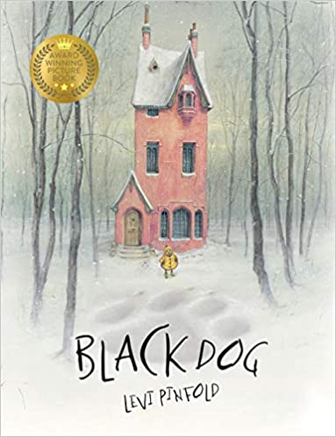Year 4 Autumn 1

Dear Parents and Carers,

We hope you and your child have had a relaxing summer break and are now ready to start the new school year revitalised and ready for some hard work!

|  |  |
| --- | --- |
| English | In English, this term, we will be studying the book ‘Black dog’ by Levi Pinfold and using the text to support our year 4 writing skills.  We will cover the national curriculum grammar, punctuation and spelling targets such as, fronted adverbials, adverbs to express time and place and paragraphs around a theme. |
| Reading comprehension | As well as reading every day, it is also extremely important to practise asking and answering questions about the text. Reading comprehension forms a prominent part of the curriculum and we will practise the skills of answering retrieval and inference questions. |
| Maths | In numeracy we will identify the place value in large whole numbers and be able to use this knowledge to round, order and compare numbers.  We will practise using the formal written methods of addition, subtraction and multiplication with increasingly large numbers. |
| Science | Science this term covers the topic of Animals Including Humans. We will look at the digestive system. Children will be encouraged to think about their health and how important it is to eat a healthy diet, including looking after our teeth. |
| PE | We will be practising dance and preparing a Diwali dance for the Dance Festival in November. |
| Music | In music this term, the children will be continuing their singing assemblies. |
| Geography | This term, our topic will be Geography and we will be studying the green planet. This includes looking at the world’s flora and fauna. |
| Art | In art, we will be focussing on colour. We will be using a variety of mediums and we will mix a variety of colours to create different tones and shades. |
| RE | In RE we are going to look at and learn about Hinduism and what is means to be Hindi in Britain today. |
| ICT | In computing lesson, we will be looking at computer science and online safety including privacy and security. |

Additional information

PE

This year our PE session is on a Wednesday. Please note that your child will need to have the correct PE kit in school every day.

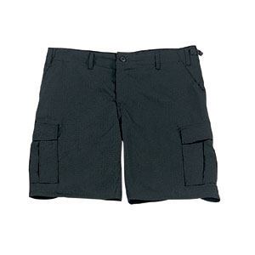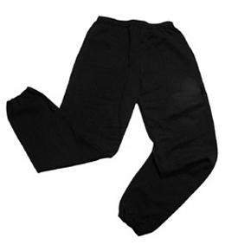Their kit should consist of a white t-shirt, dark blue or black shorts/jogging bottoms, jumper and trainers/daps.



**No jewellery is to be worn; hair needs to be tied back and head scarves must be short and tight fitting.** These are all to ensure the safety of your child.

READING

Every child will have their own individual log in for Rising Stars (<https://www.risingstars-uk.com> ). Please ensure that your child is using Rising Stars to complete their homework each week. Please take the opportunity to support your child whilst they are working on Rising Stars. It is also important that you listen to your child read books as much as possible, as this will help both their reading and writing abilities. Reading comprehension is a big focus so they will need your support to help practise the skills we will teach. You can help at home by asking your child questions about their book after they have read such as ‘How do you know he is angry?’ or ‘Why is she happy?’

HOMEWORK

Your child will receive homework each week. This homework will be set online on a **Friday** and should be completed by the following **Wednesday**. Each week, your child will be set one reading comprehension task and one spelling task on Rising Stars. In addition, a spelling activity will be set. There will be a piece of Maths Homework, which will enable your child to practise what they have been learning in class that week, the previous week, as well as work from previous terms as well.

If you have any questions, please do not hesitate to contact the school office.

Many Thanks

Miss Truman, Miss Leach and Miss Gheorghe

The Year 4 Team