Year 3 Spring 2 Newsletter
Dear Parents and Carers,
Welcome to Term 4! We hope you had a good half term, and are ready to head back to school after March 8th. As always, we have another busy term ahead.

PE
Your child will continue to have PE on a Monday this term. Please note that your child will need to come to school already dressed in their PE kit. Their kit should consist of a white t-shirt, dark blue or black jogging bottoms and hoody or sweatshirt and trainers suitable for outdoors. Please make sure your child is dressed appropriately for the colder weather.
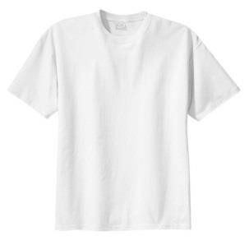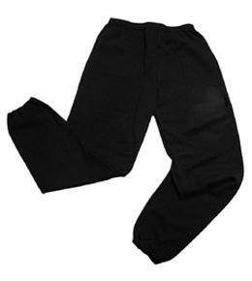
No jewellery is to be worn; hair needs to be tied back and head scarves must be short and tight fitting. These are all to ensure the safety of your child.

READING
Every child will have their own individual log in for Reading Eggs (www.readingeggs.co.uk) or ReadingPlanet.co.uk. Please ensure that your child is reading 4 times a week for at least 15 minutes on each occasion. Please also take the opportunity to support your child whilst they are working on Reading Eggs. It is also important that you listen to your child read other books as much as possible as this will help both their reading and writing abilities. Reading comprehension is a big focus so they will need your support to help practice the skills we will teach. You can help at home by asking your child questions about their book after they have read such as ‘How do you know he is angry?’ or ‘Why is she happy?’

HOMEWORK
Your child will be set a variety of homework each week, mostly through PurpleMash. There will be weekly spellings and a maths or times tables activity. This will help us reduce the amount of paper passing between school and home. If you do not have reliable internet or devices at home, please let your child’s teacher know and paper alternatives can be arranged.
Please support your child in completing their homework, it is an important way to review, check and support their learning.

WATER BOTTLES
Please make sure your child brings a water bottle to school each day as we are unable to provide cups or spare bottles as a result of Covid-19.

Many Thanks

Mrs McGinn, Mrs Hill, Mrs Kearns and Ms Edgington

