Key Vocabulary and Definitions:

|  |  |
| --- | --- |
| Aerial view | Sometimes called birds-eye view. It is an image from above, as if looking down on something. |
| Human features | Ways in which people have affected an area |
| Key | Shows what the colours or symbols on a map mean. |
| Landmark | An object or feature of a place that is easily seen and recognised from a distance. |
| Physical features | The natural features of an area, such as mountains, deserts, rivers, and oceans. |
| Population | The number of people living in a country, city, or area |
| Rural | An area of countryside |
| Scale | The size of things on a map compared to real life |
| Sketch map | A roughly drawn map that shows only basic details |
| Urban | An area in and around a city or town |

What should I already know?

* Understand geographical similarities and differences through studying the human and physical geography of a small area of the UK;
* Devise a simple map; and use and construct basic symbols in a key.

Geographical Skills:

* Name and locate counties and cities of the UK, geographical regions and their identifying characteristics;
* Describe and understand key aspects of physical geography including key topographical features and land use patterns;
* Understand geographical similarities and differences through studying the human and physical geography of a region of the UK
* Use fieldwork to observe, measure and record the human and physical features in the local area using a range of methods, including sketch maps, plans and graphs

Teaching Sequence

1. To use simple sketch maps that show how land is used.
2. To use a key on a map to show how land is used.
3. To create a simple sketch map to show how land is used (Local Area Walk).
4. To create a simple map to show how land is used.
5. To describe land use in urban and rural areas in the UK
6. To explain how land is used for different types of farming

Blooms Taxonomy – Specific Verbs to Use in Lesson Aims

Knowledge: Describe, find, identify, list, locate, name, recognise, retrieve Comprehension: Classify, compare, explain, infer, interpret, paraphrase, summarise Application: Carry out, implement, use Analysis: Deconstruct, Organise, outline, structure Synthesis: Construct, design, devise, invent, make, plan, produce, Evaluation: Appraise, assess, choose,

Key Knowledge

Sketch Map

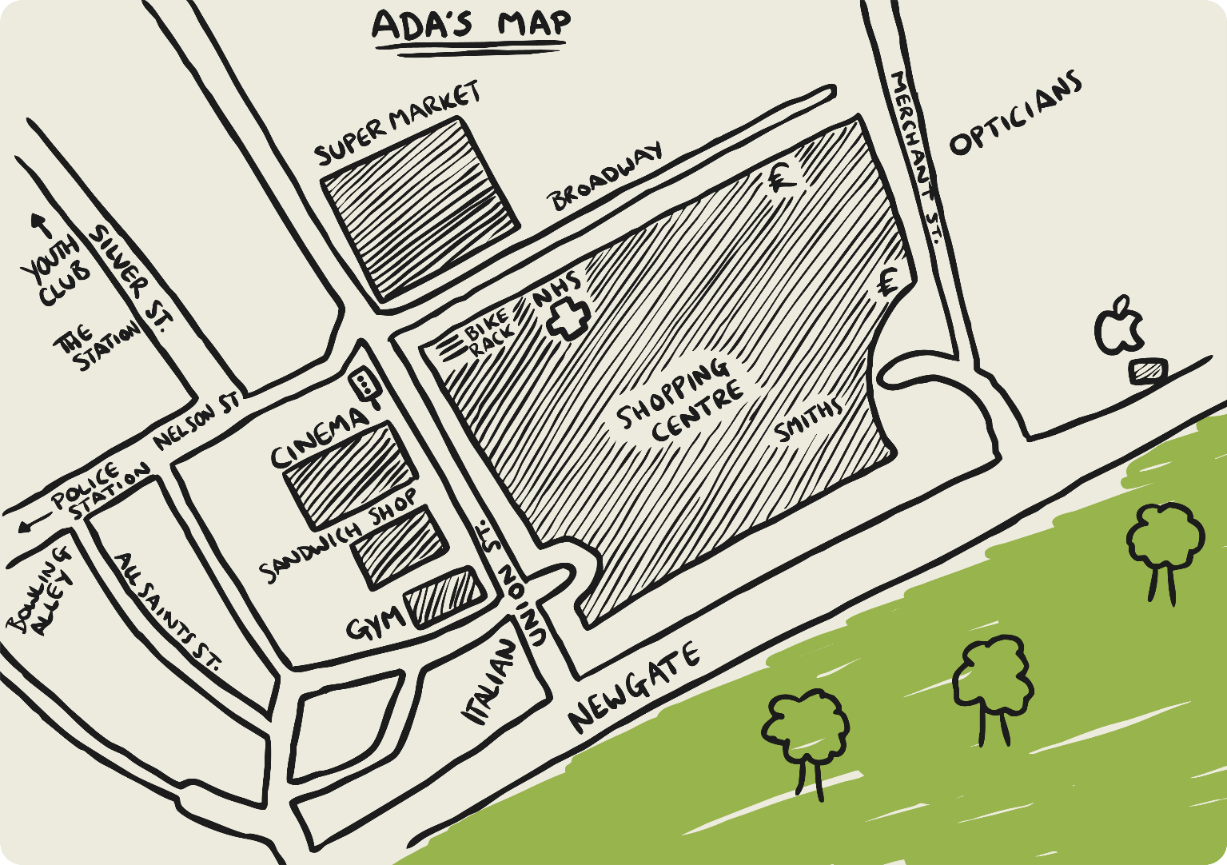

Aerial Map

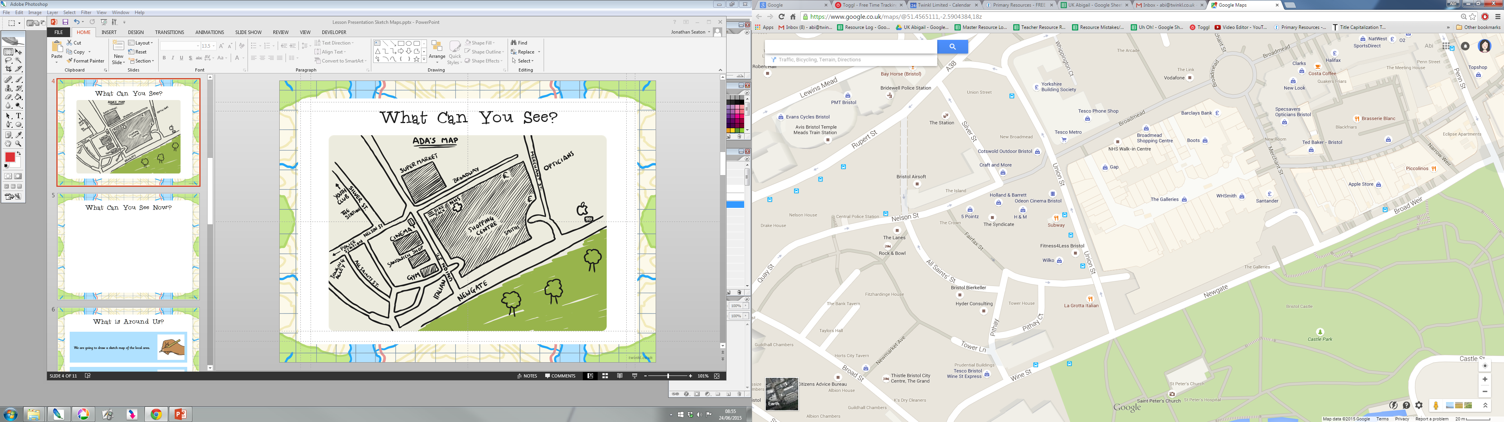

Land Use in the UK

