Year 3 Term 1

Dear Parents and Carers,

Firstly, we all hope that you and your children have had a restful and enjoyable summer break and are now ready to start the new school year revitalised and ready for some hard work!

|  |  |
| --- | --- |
| English | In English, we will be studying the book, ‘The Day the Crayons Came Home.’ The children will explore the book and the characters before writing a fictional description based around the story. The children will then look at letter and postcard writing for their non-fiction outcome. |
| Reading comprehension | In Reading, we will be looking closely at our English text, ‘The Day the Crayons Came Home’. The children will practise their scanning and quotation skills to aid their reading comprehension understanding. |
| Maths | In maths, we will be looking at number and place value. We will be focusing on 3-digit numbers, counting in 10s, 50s and 100s as well as practising ordering and number line skills. |
| Science | Our science topic this term is Plants. The children will learn to identify and describe the functions of different parts of flowering plants, explore the requirements of plants for life and growth and investigate the way in which water is transported within plants. |
| PE | In PE we will be learning to play Tag Rugby. The children will look at improving their accuracy when throwing the ball, being a member of a team and describing the effects of exercise e.g. sweating, raised heart rate. |
| Geography | In our geography topic this term we will study ‘The UK’. We will explore the countries, cities, the main rivers and seas of the UK using an atlas or map. |
| Music | We will be learning the song, Three little birds. |
| RE | In RE, the big question we will be considering is ‘What does it mean to be a Christian in Britain today? |
| Computing | In computing lessons, we will be looking at information technology: retrieving files and compiling a poster based around our Geography Topic. |
| PSHE | In PSHE we will be looking at the topic ‘Being Me in My World.’ The children will look at getting to know each other, what their dream school would be like and kindness. We will also look at two of our school values, Respect and Responsibility. |

Additional information

PE

Please note that your child will need to have the correct PE kit in school **every day.**

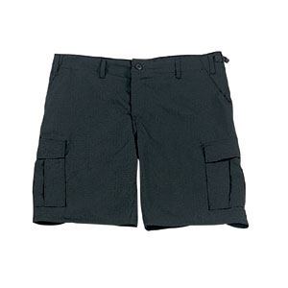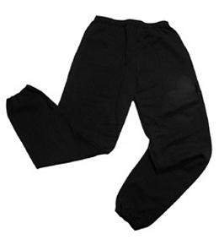Their kit should consist of a white t-shirt, dark blue or black shorts/jogging bottoms and trainers/daps.

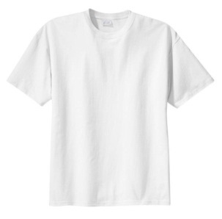

**No jewellery is to be worn; hair needs to be tied back and head scarves must be short and tight fitting.** These are all to ensure the safety of your child.

READING

Every child will have their own individual log in for Rising Stars, Reading Planet. Please ensure that your child is reading regularly at home and please take the opportunity to support your child whilst they are working on Reading Planet. It is also important that you listen to your child read books as much as possible as this will help both their reading and writing abilities. Reading comprehension is a big focus so they will need your support to help practice the skills we will teach. You can help at home by asking your child questions about their book after they have read such as ‘How do you know he is angry?’ or ‘Why is she happy?’

HOMEWORK

Your child will bring home a list of spellings which they will be expected to learn each week. There will also be maths homework. Your child will bring their homework folder home on a Friday with an expectation that they are back in school by Wednesday morning.

If you have any questions, please do not hesitate to come in and see us at the end of the school day.

Many Thanks

Mrs Walker, Miss Cooper and Mrs Ramzan.

The Year Three Team