What should I already know?

* To recognise different parts of a school or office network e.g. server, switch, router, client, Wi-Fi point, and explain the purpose of each.
* To use online communication and collaboration tools for different purposes
* To use a search engine efficiently by filtering and begin to understand how results are selected or ranked

Key Vocabulary and Definitions:

|  |  |
| --- | --- |
| Audience | A piece of electronic equipment adapted for a purpose. |
| Collaboration | The action of working with someone together to get an end product. |
| Data base | Organised data collection. |
| Devices | A piece of electronic equipment adapted for a purpose. |
| Filtering | A computer program to stream another program. |
| Network | A digital communication which allows people to share resources. |
| Server | A computer that provides data to other computers. |
| Search Engine | A program that searches for and identifies items in a data base that relate to words the person has used to find something. |
|  |  |
|  |  |
|  |  |

Computing Skills:

* Show I understand my responsibilities for the well-being of others in my online social group.
* To explain how impulsive and rash communications online may cause problems (e.g. flaming, content produced in live streaming).
* To demonstrate how I would support others (including those who are having difficulties) online and demonstrate ways of reporting problems online for both myself and my friends.

Teaching Sequence

1. To recognise the role every online user has on social media.
2. To understand what causes dysfunction when using a range of online communication and collaboration tools independently.
3. To identify the different options that are available to support me online when I am in need of help.

Blooms Taxonomy – Specific Verbs to Use in Lesson Aims

Knowledge: Describe, find, identify, list, locate, name, recognise, retrieve Comprehension: Classify, compare, explain, infer, interpret, paraphrase, summarise Application: Carry out, implement, use Analysis: Deconstruct, Organise, outline, structure Synthesis: Construct, design, devise, invent, make, plan, produce, Evaluation: Appraise, assess, choose,

Key Knowledge

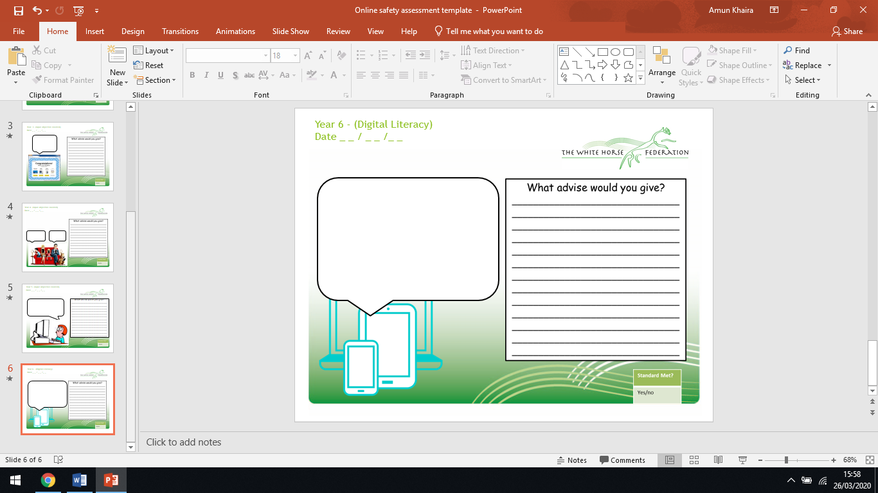

I am on a social media platform that I should be and I have been getting a lot of hateful comments said to me about my photos. I want to tell an adult but I am worried that I will get told off for being on the social media outlet in the first place.