What should I already know?

* Begin to use 4 figure co-ordinates to locate features on a map
* Use 8 compass points
* Draw a sketch map using symbols and a key
* Use/recognise OS map symbols

Key Vocabulary and Definitions:

|  |  |
| --- | --- |
| Atlas | An atlas is a collection of maps; it is typically a bundle of maps of Earth or a region of Earth. |
| Compass | Device used for navigation and direction. |
| Coordinates | Numbers on a grid that locate a specific point. |
| Eastings/ Northings |  |
| Grid references | Using the 2 digits of the easting and the 2 digits of the northing creates a four-figure grid reference. |
| Index | An alphabetical list of names or subjects with reference to the pages on which they are mentioned. |
| Key | Provides definitions of the symbols. |
| Symbol | Small keys dotted around the maps to identify key places |

Geography Skills:

* Use 8 compass points confidently and accurately
* Use 4 figure co-ordinates confidently to locate features on a map
* Begin to use 6 figure grid refs; use latitude and longitude on atlas map
* Follow a short route on an OS map Describe features shown on OS map
* Locate places on a world map
* Use atlases to find out about other features of places. (e.g. mountain regions, weather patterns)

Teaching Sequence

1. To understand the different types of maps
2. To navigate around a map or atlas
3. To know what device you can use to support your navigation and direction
4. To plan an exciting journey…
5. To know how maps were used in different periods of time

Blooms Taxonomy – Specific Verbs to Use in Lesson Aims

Knowledge: Describe, find, identify, list, locate, name, recognise, retrieve Comprehension: Classify, compare, explain, infer, interpret, paraphrase, summarise Application: Carry out, implement, use Analysis: Deconstruct, Organise, outline, structure Synthesis: Construct, design, devise, invent, make, plan, produce, Evaluation: Appraise, assess, choose,

Key Knowledge

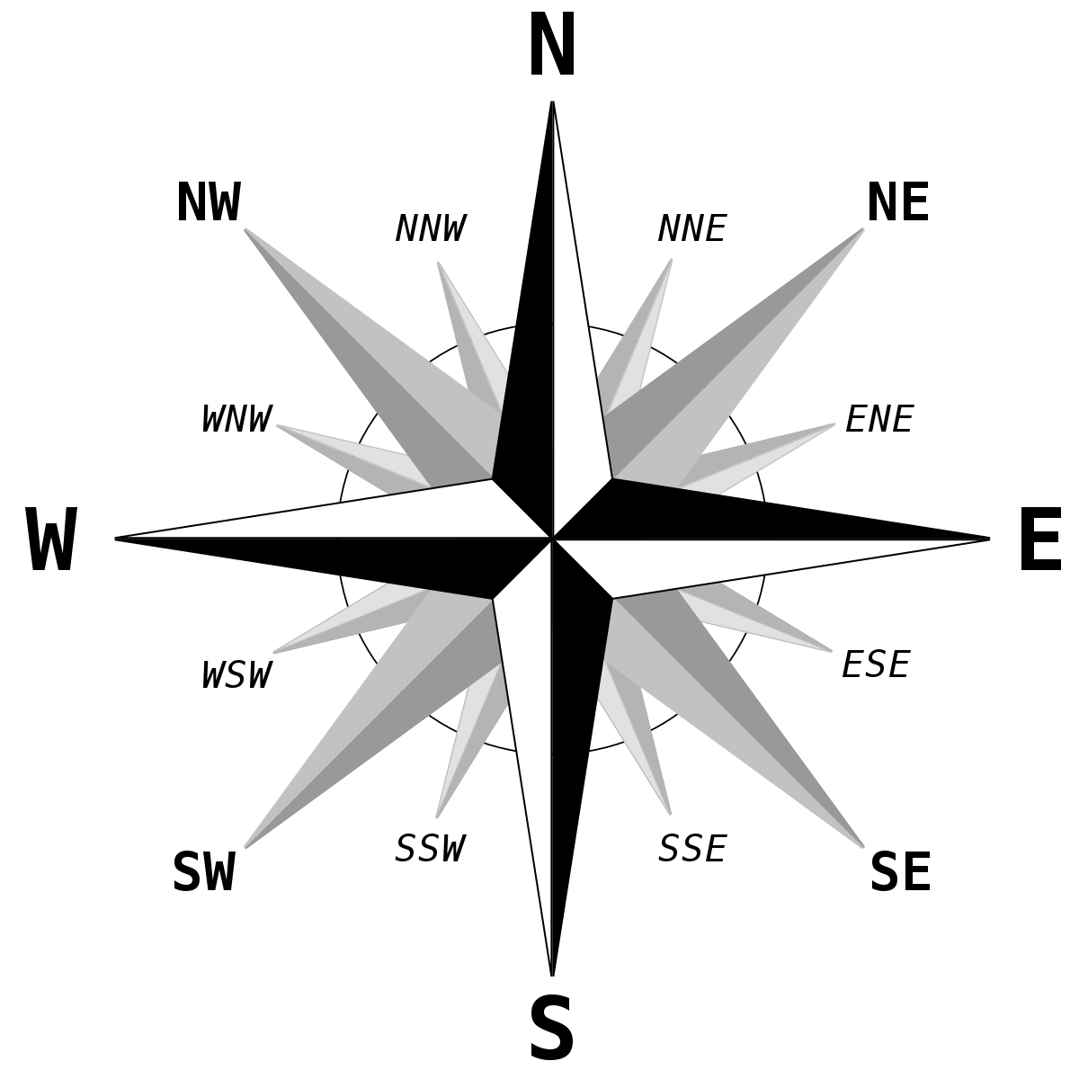

Can you recall an acronym to remember the compass points?

