Year 5 Summer Newsletter – Term 5

Dear Parents and Carers,

We hope you have had a lovely half term break and you are ready for the last term of Year 5! As it is getting warmer, please ensure that children always come to school with a water bottle and a hat. Sun cream should be applied at home, though some may wish to have a small bottle with them for extra use. We will not be providing sun cream at school.

|  |  |
| --- | --- |
| English | This term, we are going to be reading The Nowhere Emporium by Ross MacKenzie. We’re going to be using the book to help with ideas to create a new setting description using figurative language to develop atmosphere. We will be learning how the choice of vocabulary will affect the mood and atmosphere in the narrative. Later in the term, we will move on to write a non-chronological report using The Nowhere Emporium for inspiration. We will learn about how formal language and third person will ensure the report is appropriate. |
| Reading | In Guided Reading, we will be continuing to read The Nowhere Emporium. Over the term, we will continue to recap skills such as understanding the meaning of words in context and finding and retrieving words in a text. |
| Maths | We will be learning how to measure and draw acute, obtuse and reflex angles and measure angles on a line and around a point. Accuracy is very important when measuring the angles as the measurement needs to be accurate within 2°. After angles, we will move on to learn about regular and irregular polygons and translating (moving) and reflecting shapes within and across axes. The last skills to be learnt will be reading a 24-hour digital clock and converting between 12-hour analogue and 24-hour notation. Using that information, we will then learn how to read and interpret information in tables and line graphs. Practising how to read an analogue clock at home will be very useful! |
| PE | We will be practising our rounders skills this term. We will focus on throwing and catching techniques used for bowling and fielding. After, we will learn the rules of rounders and how to score points and catch the opposition out! |
| Geography | In geography, we will be answering the question ‘How did a sandwich change Swindon?’. To learn about our place in the UK, we will look at a map of the UK and find out about how regions and counties split the country up. Then, we will learn about the changes Swindon has been through using a range of maps from the 1800s to the current day. Knowing the 8 points of a compass is an important skill and that will be covered alongside learning how to use grid references. |
| Music | This term, our song will be The Fresh Prince of Bel-Air. We will be learning to sing the song, ensuring that our voices are being used accurately and we are able to follow the rhythm and beat of the music. |
| RE | In RE our big question is: What does it mean to be a Muslim in Britain today? The children will describe the Five Pillars of Islam, identify three reasons why the Holy Qur’an is important to Muslims and make connections between key functions of the mosque and the beliefs of Muslims. |
| Computing | In Computing, we will be looking at Digital Literacy. We will learn about shortcuts on a keyboard to speed up creating documents. Simultaneously, we will be creating a leaflet, helping us to learn how this is done, and how to edit and revise work that has already been saved. In Online Safety, children will be continuing to learn how to stay safe online and how important it is to be responsible and respectful at all times. |

Additional Information

PE

PE lessons will continue to take place on Thursdays. Please ensure that children are wearing appropriate clothing for the warmer weather and bring a hat and water bottle.

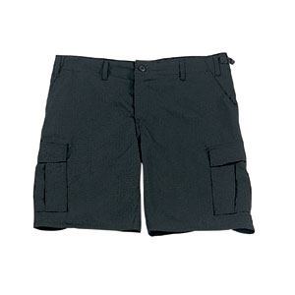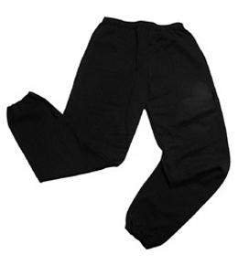Their kit should consist of a white t-shirt, dark blue or black shorts/jogging bottoms and trainers/daps.



**No jewellery is to be worn; hair needs to be tied back and head scarves must be short and tight fitting.** These are all to ensure the safety of your child.

Reading

Please listen to your child read every day, as this will help both their reading and writing abilities. They all have their own login for Reading Eggs, which gives them access to thousands of books. They may also bring home a classroom book they have chosen themselves. Your child can also read books from home or from a library. Reading comprehension is a big focus so they will need your support to help practice the skills we will teach. You can help at home by asking your child questions about their book after they have read such as ‘How do you know he is angry?’ or ‘Why is she happy?’

Homework

Every week, your child will have a Reading Eggs assignment, spellings to learn and times tables. Reading Eggs will need to be completed by Wednesday. Spelling and times tables tests will be on Fridays.

If you have any questions, please do not hesitate to come and see us at the end of the school day.

Many Thanks

Mrs Waller, Miss Price and Miss Khaira

The Year Five Team