Year 5 Autumn Newsletter – Term 2

Dear Parents and Carers,

We hope you are well and that your children have enjoyed their first term back at Drove!

|  |  |
| --- | --- |
| English | In English, our next book for the term will be ‘The Boy at the Back of the Class.’ This book is all about a refugee boy coming to a UK school from a warzone. We will be looking at retelling the boy’s story about how it may feel leaving your family and country. We will also be writing a newspaper article about the narrators visit to Buckingham Palace. Each week, we will have a different skill that we will be focusing on. This term, we will be looking at using commas and dashes, relative pronouns and defining and non-defining relative clauses. We will also have new words of the week. |
| Reading | We’re going to be reading ‘The Boy at the Back of the Class’ by Onjali Q. Rauf. We will be practising retrieval skills, learning how to use Point, Evidence, Explanation (P.E.E) to structure an answer. Later in the term, we will look at a range of texts and newspaper articles to support our writing. |
| Maths | This term, Year 5 will be expanding their addition and subtraction knowledge by calculating 4-digit and 4-digit including regrouping and exchanging in a number of columns. They will then move on to adding and subtracting decimal numbers up to 3 decimal places. To build on their knowledge of decimal numbers, Year 5 will be multiplying and dividing by 10, 100 and 1000 and recognising patterns when calculating them. Towards the end of Term 2, the children will look at properties of numbers and learn about prime and composite numbers and then learn about squared and cubed numbers and how to calculate them. Year 5 will also continue with arithmetic, practicing key skills from Year 4 and being able to complete them mentally or with small jottings. They will need to continue to practice all multiplication and division facts to enable them to progress through term 3 when they move on to multiplication and division. |
| Science | Year 5 will be learning about properties of materials and what they are most suitable for. They will then be investigating thermal conductors and insulators and looking at which materials will make a lightbulb shine the brightest. Year 5 will also look at mixing and separating liquids and the different ways in which it can be done. |
| PE | PE will be Tennis this term. Children will learn the rules of tennis as well as building their confidence in fore hand and back hand shots to return the ball. We will discuss tactical positioning on the court to compete in competitive games of singles and doubles matches. |
| Music | This term we will be learning how to sing the song ‘Dancing In The Street’ by David Bowie. We will be learning how to follow the beat, tempo and actions. |
| Topic | This term our topic will be history based. We will be learning about all the Maya’s and their culture. We will also be learning how to write like a Mayan and learning about their language. At the end of the term, we will also be learning about their diet and what food was available to them. |
| RE | In RE our big question is: If God is everywhere why go to a place of worship? We will be focussing on Christianity and exploring different points of view about gods. |
| Computing | In computing we will be learning about online bullying. We will be using our SMART rules during our lessons to show how important being safe online is. We will look at how anyone can get help if they are being bullied online and identify when to tell a trusted adult. The children will also be learning about computer science and how to make programmes more complex with algorithms using sequences. |

Additional Information

PE

Year 5 PE is on a Thursday afternoon, however, please note that your child will need to have the correct PE kit in school **every day.**

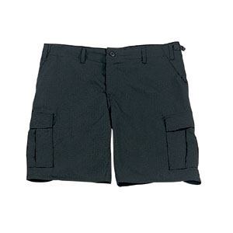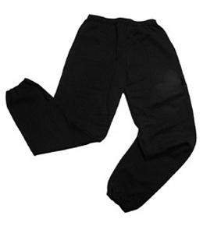Their kit should consist of a white t-shirt, dark blue or black shorts/jogging bottoms and trainers/daps.



No jewellery is to be worn; hair needs to be tied back and head scarves must be short and tight fitting. These are all to ensure the safety of your child.

**If children wear earrings, they need to be able to take them out (independently) for PE lessons.**

READING

Please listen to your child read every day as this will help both their reading and writing abilities. They all have their own login for Rising Stars (using their old Reading Eggs username and password). In school, we will be checking.

HOMEWORK

Your child will bring maths and spelling homework home on a Friday, to be returned by the following Wednesday. Spellings will be tested weekly on a Friday. They will also be set a text to read on Rising Stars which will need to be completed on Wednesday.

If you have any questions, please do not hesitate to come and see us at the end of the school day.

Many Thanks

Mrs Parker, Miss Khaira and Mrs Barder

The Year Five Team