Year 5 Autumn Newsletter – Term 1

Dear Parents and Carers,

We hope you are keeping well and your children are happy to be back with us at school for a brand-new school year!

|  |  |
| --- | --- |
| English | In English, our first book for the term will ‘The Man Who Walked between the Towers.’ This is a fantastic book based on a true story about an acrobat called Philippe Petit who walked between the famous World Trade Centre. We will be looking at characterisation for narratives and non-chronological reports. Each week, we will have a different skill that we will be focusing on. This term, we will be looking at using subordinating clauses, fronted adverbials and informal and formal language. We will also have a new word of the week |
| Reading | We’re going to be reading ‘The Man Who Walked between the Towers’ by Mordicai Gerstein. We will be practising inferal skills, learning how to use Point, Evidence, Explanation (P.E.E) to structure an answer. Later in the term, we will look at a range of information texts and non-chronological reports to support our writing. |
| Maths | In maths, we will begin with place value. This will mainly focus on identifying place value markers, reading and writing numerals as digits and words as well as rounding numbers to the nearest 1000, 10,000 and 100,00. We will also be using MOT lessons to recap multiplication facts and skills learnt during Year 4. |
| Science | In Science, we will be finding out about forces. We will carry out lots of experiments to discover the effects of gravity, water resistance, air resistance and levers. |
| PE | In PE, we will be covering dance. We will be using our PE lessons to create and learn a dance for the Drove Dance Festival at the start of Term 2 to celebrate Diwali. We will be learning different actions and ways of moving using direction and levels to make the dances interesting. We will encourage use of formations, dynamics, canon, unison, direction and levels. |
| Design Technology | We will be learning about various types of bridges and what makes them strong. We will learn the correct vocabulary to describe why some bridges are stronger and the reasons behind the structure. In class, the children will be using tools to design and make their own bridges and will then test them to see if they safe. |
| Geography | This term our topic will be geography based. We will be identifying countries of North America and some states. We will use geographical terminology to describe the location and characteristics of a range of places across the Americas. Furthermore, we will develop our understanding of the climates and how animals and plants are adapted to live there. |
| RE | In RE our big question is: Why do some people think that God exists? We will be focussing on Christianity and exploring different points of view about gods. |
| Computing | In computing we will be learning about how to stay safe online. We will be using our SMART rules during our lessons to show how important being safe online is. We will look at how to create safe passwords, discussing what we can do if we come across something we do not like and how to deal with this. Children will also learn how to save their work on the cloud, create and modify work and evaluate their documents. |

Additional Information

PE

Year 5 PE is on a Thursday afternoon, however, please note that your child will need to have the correct PE kit in school **every day.**

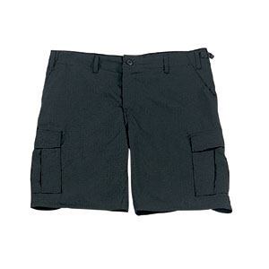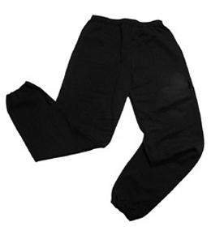Their kit should consist of a white t-shirt, dark blue or black shorts/jogging bottoms and trainers/daps.

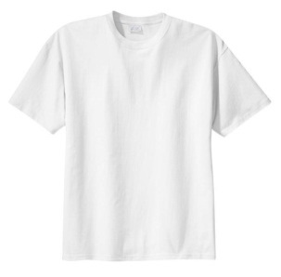

No jewellery is to be worn; hair needs to be tied back and head scarves must be short and tight fitting. These are all to ensure the safety of your child.

**If children wear earrings, they need to be able to take them out (independently) for PE lessons.**

READING

Please listen to your child read every day as this will help both their reading and writing abilities. They all have their own login for Rising Stars (using their old Reading Eggs username and password). In school, we will be checking

HOMEWORK

Your child will bring maths and spelling homework home on a Friday, to be returned by the following Wednesday. Spellings will be tested weekly on a Friday. They will also be set a text to read on Rising Stars which will need to be completed on Wednesday.

If you have any questions, please do not hesitate to come and see us at the end of the school day.

Many Thanks

Mrs Parker, Miss Khaira and Mrs Barder

The Year Five Team