Key Vocabulary and Definitions:

|  |  |
| --- | --- |
| Diet | The food and drink that a person or animal usually has. |
| Endoskeleton | A skeleton found inside the body. |
| Exoskeleton | An external (outside) skeleton that supports and protects an animal's body. |
| Invertebrate | An animal without a backbone. |
| Muscle | Tissue in the body of animals and humans that moves parts of the body. |
| Nutrients | A substance that is needed for healthy growth and development. |
| Nutrition | The process by which the body nourishes itself by transforming food into energy. |
| Skeleton | A framework of bones that support the body and protect softer body parts. |
| Vertebrate | An animal with a backbone. |
|  |  |

What should I already know?

* To find out about and describe the basic needs of animals, including humans, for

survival (water, food and air)

* To describe the importance for humans of exercise, eating the right amounts of different types of food, and hygiene.

Scientific Skills:

* To use pictures, writing, diagrams and tables as directed by their teacher;
* To record their observations in written, pictorial and diagrammatic forms;
* To make relevant observations;
* To select the appropriate format to record their observations;
* To begin to offer explanations for what they see and communicate in a scientific way what they have found out.

Teaching Sequence

1. To explain why animals, including humans, need the right type of nutrients.
2. To compare and group animals by their diet.
3. To sort animals based on their skeletons.
4. To know that humans and some other animals have skeletons and name some of the bones.
5. To identify and explain the 3 main functions of a skeleton .
6. To know why we need muscles to move.

Blooms Taxonomy – Specific Verbs to Use in Lesson Aims

Knowledge: Describe, find, identify, list, locate, name, recognise, retrieve Comprehension: Classify, compare, explain, infer, interpret, paraphrase, summarise Application: Carry out, implement, use Analysis: Deconstruct, Organise, outline, structure Synthesis: Construct, design, devise, invent, make, plan, produce, Evaluation: Appraise, assess, choose,

Key Knowledge

Food Groups and Types of Nutrients  
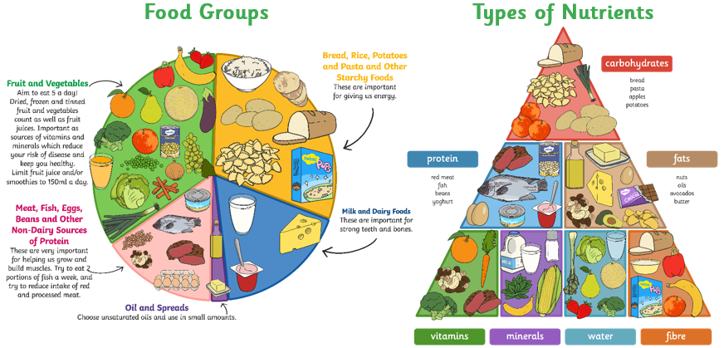

Human Skeleton

