Year 3 Term 2

Dear Parents and Carers,

We hope that you’ve had an enjoyable half term and that your children are ready for Term two. Our topic this term is ‘Stone age’ and we have lots of fun activities planned for the children around it.

|  |  |
| --- | --- |
| English | The high-quality text that we will be using this term is ‘Stoneage Boy.’ The children will explore the book and its characters before writing a fictional description based around the story. The children will create a story with a similar theme and for the non-fiction outcome, they will be writing instructions. |
| Reading comprehension | In Reading, we will be looking closely at our English text, ‘Stoneage Boy’. The children will make inferences from the text and begin to explain and justify inferences with evidence from the text. |
| Maths | In Maths this term, the children will be building 3, 4 and 8times tables and learn about the different mental methods to recall times tables facts. |
| Science | Our science topic this term is ‘Rocks’. The children will learn to identify naturally occurring rocks and explore their uses. They will also investigate the hardness and permeability of rocks and group different types of rocks according to their properties. |
| PE | In PE we will be learning to play handball. The children will look at improving their throwing and catching including throwing accurately at a target to score points. They will also be aware of the importance of using space and compare and discuss tactics in a game situation. |
| History | In our History topic this term we will study ‘The Stone Age’. We will explore and understand the term ‘prehistory’ and place the period into the context of British History. The children will also understand how the hunter-gatherers survived in the Stone Age and examine sources of evidence about the Stone Age. |
| RE | In RE, the big question we will be considering is ‘What does it mean to be a Christian in Britain today? |
| Computing | In computing we are looking at computer science. We will be discussing algorithms and predicting what will happen based around a set of instructions. We will also look at coding using Purple Mash. |
| PSHE | In PSHE we will be looking at the topic ‘Celebrating differences.’ The children will understand that everyone’s family is different and important to them, and that conflict can arise in families. Children will also learn about what bullying is and how to use kind words as some words can be hurtful. Our school values for November and December will be Acceptance and Caring. |
| Art | We are being inspired by the stone age to create our artwork using charcoal and paint |

Additional information

PE

Please note that your child will need to have the correct PE kit in school **every day.**

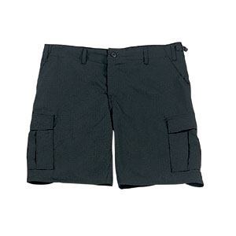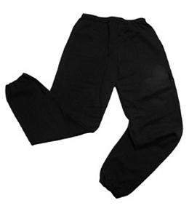Their kit should consist of a white t-shirt, dark blue or black shorts/jogging bottoms and trainers/daps.



**No jewellery is to be worn; hair needs to be tied back and head scarves must be short and tight fitting.** These are all to ensure the safety of your child.

READING

Every child will have their own individual log in for Rising Stars, Reading Planet. Please ensure that your child is reading regularly at home and please take the opportunity to support your child whilst they are working on Reading Planet. It is also important that you listen to your child read books as much as possible as this will help both their reading and writing abilities. Reading comprehension is a big focus so they will need your support to help practice the skills we will teach. You can help at home by asking your child questions about their book after they have read such as ‘How do you know he is angry?’ or ‘Why is she happy?’

HOMEWORK

Your child will bring home a list of spellings which they will be expected to learn each week. There will also be maths homework. Your child will bring their homework folder home on a Friday with an expectation that they are back in school by Wednesday morning.

If you have any questions, please do not hesitate to come in and see us at the end of the school day.

Many Thanks

Mrs Walker, Miss Cooper and Mrs Ramzan.

The Year Three Team