Year 6 Term 5

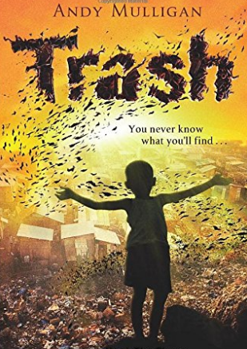

Dear Parents and Carers,

Suddenly we have arrived at Term 5 ready for 2 more terms of learning in the warmer and sunnier weather. Hopefully, as restrictions continue to be lifted, we can look forward to continue to slowly return back to a more normal school routine. We are certainly planning lots of exciting activities for the children over term 5 and 6!

|  |  |
| --- | --- |
| English | In English, this term, we will be studying the book Trash and using the text to support our year 6 writing skills. We will use the book as inspiration for our writing which will develop skills in both fiction and non-fiction genres. Our two three week writing phases will culminate in a newspaper report and a narrative.  We will continue to cover the national curriculum grammar, punctuation and spelling targets with built in grammar lessons looking at word classes and sentence construction. |
| Reading comprehension | As well as reading every day, it is also extremely important to practise asking and answering questions about the text. Reading comprehension forms a prominent part of the curriculum in year six and we will practise the skills of answering inference, literal and author’s intent questions. |
| Maths | In maths, we will be looking at area, perimeter, drawing 2D shapes, classifying 3D shapes, volume, plotting points on a graph and reflecting and translation. These are core skills the children will need as they move forward with their maths into year 7. |
| Science | Our science topic this term is Light. We will be looking at the spectrum and what white light is made up of. We will also look at how light bends and refracts. |
| PE | In PE we will continue with athletics, with one class going up to the County Ground every third week. |
| History | In our history topic this term we will study the main events of the Islamic Golden Age. We will study the beginnings of Islam and the importance of Baghdad in this unique period in history from the 8th to the 14th century. |
| Art | We will continue with the arts award project work in our art lessons. |
| RE | In RE we will be considering and comparing the beliefs of Christians and Humanists. |
| Computing | In computing lessons, we will be looking at online digital literacy and studying technology relating to the continuing development of the internet. |

Additional Information

PE

Please note that your child will need to **wear the correct PE kit to school** **every Monday for PE.**

Children will be in their PE kit all day so there will be no need to bring in their school clothes.

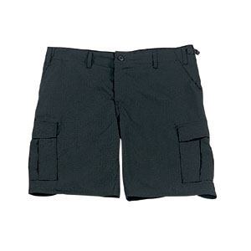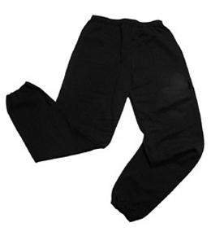Their kit should consist of a white t-shirt, dark blue or black shorts/jogging bottoms and trainers/daps.

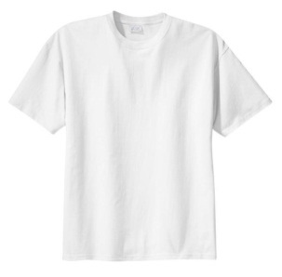

**No jewellery is to be worn; hair needs to be tied back and head scarves must be short and tight fitting.** These are all to ensure the safety of your child.

READING

Please listen to your child read every night as this will help both their reading and writing abilities. There are a wide variety of books available on ‘Reading Eggs’ that children can choose to read at home as an additional to their reading comprehension homework. Reading comprehension is a big focus so they will need your support to help practice the skills we will teach. You can help at home by asking your child questions about their book after they have read it.

HOMEWORK

Homework is set on a Friday via ‘Reading Eggs’. They will be required to complete one reading comprehension and one spelling task per week. Homework is to be completed by the following Friday of every week. They may also be set additional homework via Purple Mash. For both ‘Reading Eggs’ and ‘Purple Mash’, passwords and usernames have been given out to the children at the start of the year. If there are any problems with access, children should inform their teacher as soon as possible.

Many Thanks,

Miss Truman, Mrs Vernon and Miss Cooper

The Year Six Team