Year 5 Autumn Newsletter – Term 1

Dear Parents and Carers,

We hope you are keeping well and your children are happy to be back with us at school for a brand-new school year!

|  |  |
| --- | --- |
| English | In English, our first book for the term will be ‘The Man Who Walked between the Towers.’ This is a fantastic book based on a true story about an acrobat called Philippe Petit who walked between the famous World Trade Centre. We will be looking at setting descriptions, diary entries and letters. Each week, we will have a different skill that we will be focusing on. This term, we will be looking at complex sentences, fronted adverbials and informal and formal language. We will also have a new word of the week. |
| Reading | We will be reading the Man who walked between the Towers by Mordicai Gerstein. You can listen to the story being read on YouTube by searching for the book title. We will be focusing on inference questions (using evidence from the text) and retrieve and record questions. |
| Maths | In maths, we will begin with place value. This will mainly focus on identifying place value markers, reading and writing numerals as digits and words as well as rounding numbers to the nearest 1000, 10,000 and 100,00 We will also |
| Science | In Science, we will be finding out about forces. We will carry out lots of experiments to discover the effects of gravity, water resistance, air resistance and levers. |
| PE | In PE we will be covering football. We will develop a broader range of techniques and skills for attacking and defending and Know and apply the basic strategic and tactical principles of attack, and to adapt them to different attacking and defending scenarios. Year 5 will be using the foundation park to practise their football skills on a Thursday afternoon. |
| Music | This year we have an exciting new scheme of work following the ‘Charanga’ music! Year 5 will be learning Bon Jovi’s ‘Livin’ on a Prayer.’ Each week, we will look at a different verse and break it down focusing on the tone and rhythm of the song. |
| Topic | This term we are learning about Crime and Punishment from the Roman times all the way up to the present day. We will be learning about the different methods of punishment and how they have altered through time, changing with the severity of the crimes being committed. |
| RE | In RE our big question is: Why do some people think God exists?  We will be looking at this from a Christian point of view, respectfully discussing why some people believe in God and others do not. Children will have the opportunity to share their thoughts and opinions. |
| Computing | In computing we will be learning about how to stay safe online. We will be using our SMART rules during our lessons to show how important being safe online is. We will look at how to create safe passwords, discussing what we can do if we come across something we do not like and how to deal with this. Children will also learn how to post work onto class blogs and how to send formal and informal emails to teachers and friends! |

Additional Information

PE

Year 5 PE is on a Thursday afternoon. During the next few terms, children will need to come to school dressed in their PE kits for the whole day. Please ensure they are in the correct clothes and that they will be warm enough, especially as we will be doing PE outside during the colder months. A good waterproof coat will be needed.

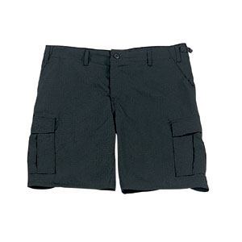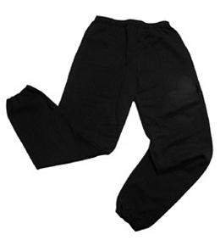Their kit should consist of a white t-shirt, dark blue or black shorts/jogging bottoms and trainers. Daps are ok but will quickly get wet if we are doing PE outside during winter, trainers would be more suitable.



No jewellery is to be worn; hair needs to be tied back and head scarves must be short and tight fitting. These are all to ensure the safety of your child.

**If children wear earrings, they need to be able to take them out (independently) for PE lessons.**

READING

Listening to your child read every day will help them to improve their fluency and comprehension. They can read their own books at home or access Reading Eggs to find age appropriate texts. Reading comprehension is vital so they will need your support to help practice the skills we will teach. You can help at home by asking your child questions about their book after they have read such as ‘How do you know he is angry?’ or ‘Why is she happy?’

HOMEWORK

Your child will be given two pieces of homework to complete on a Friday, to be returned by the following Wednesday. This will include spelling homework (which will be tested weekly) and a reading lesson both to be completed on Reading Eggs. They will frequently be given a task to complete via Purple Mash.

If you have any questions, please do not hesitate to come and see us at the end of the school day.

Many Thanks

Mrs Waller, Mrs Cuming and Miss Price

The Year Five Team