Year 3 Autumn 1 Newsletter



Dear Parents and Carers,

We hope you and your child have settled in well to the new  
routines.

PE

Your child will have PE on a Monday. Please note that your  
child will need to come to school already dressed in their PE kit.

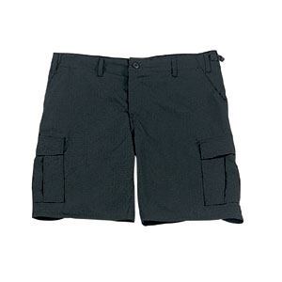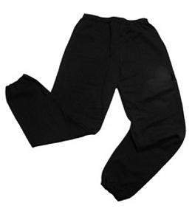Their kit should consist of a white t-shirt, dark blue or black shorts/jogging bottoms and trainers/daps. Please make sure your child is dressed appropriately for the colder weather.



**No jewellery is to be worn; hair needs to be tied back and head scarves must be short and tight fitting.** These are all to ensure the safety of your child.

READING

Every child will have their own individual log in for Reading Eggs ([www.readingeggs.co.uk](http://www.readingeggs.co.uk)). Please ensure that your child is using reading eggs at least **4 times a week** for at least 15 minutes on each occasion. Please take the opportunity to support your child whilst they are working on Reading Eggs. It is also important that you listen to your child read books as much as possible as this will help both their reading and writing abilities. Reading comprehension is a big focus so they will need your support to help practice the skills we will teach. You can help at home by asking your child questions about their book after they have read such as ‘How do you know he is angry?’ or ‘Why is she happy?’

HOMEWORK

Your child will be set a variety of homework each week, mostly through PurpleMash. There will be weekly spelling and a maths or times tables activity. This will help us reduce the amount of paper passing between school and home. If you do not have reliable internet or devices at home, please let your child’s teacher know and paper alternatives can be arranged.

Many Thanks

Mrs McGinn, Mrs Hill, Mrs Kearns and Miss Edgington

The Year Three Team