Year 6 Autumn 1

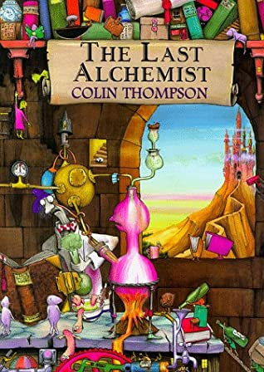

Dear Parents and Carers,

We hope you and your child have had a relaxing summer break and are now ready to start the new school year revitalised and ready for some hard work!

|  |  |
| --- | --- |
| English | In English, this term, we will be studying the book ‘The Last Alchemist’ by Colin Thompson and using the text to support our year 6 writing skills. Alongside this, we will also use the literacy shed video, The Alchemist’s Letter.  We will cover the national curriculum grammar, punctuation and spelling targets with specific grammar lessons looking at word classes and sentence construction.  We will also have separate reading comprehension lessons that focus on understanding inference and deduction questions using extracts from ‘The Last Alchemist’ . |
| Reading comprehension | As well as reading every day, it is also extremely important to practise asking and answering questions about the text. Reading comprehension forms a prominent part of the curriculum in year six and we will practise the skills of answering inference, literal and author’s intent questions. |
| Maths | In maths, we will identify the place value in large whole numbers and be able to use this knowledge to estimate, round, order and compare numbers.  We will practise using the formal written methods of addition, subtraction, multiplication and division with increasingly large numbers and begin to decide which representations of data are most appropriate and why. |
| Science | Science this term covers the topic of Animals Including Humans. We will look at the circulatory system and the digestive system. Children will be encouraged to think about their health and how important it is to eat a healthy diet and to exercise. We will also look at the effects of drugs and stimulants on our bodies. |
| PE | We will be introduced to a variety of invasion games and this term we will be learning football skills. We will build upon the skills learnt in previous which will progress our performance, both as an individual and within a team. |
| Geography | Geography this term is natural disasters, we will look at how mountains are formed, use map skills to identify lines and symbols in Snowdonia National park and look at the first successful attempt to climb Everest. |
| Art | In art, we will be focussing on colours and shapes linked to emotions and using Kandinsky as inspiration to draw our own geometric patterns. |
| RE | In RE, we are going to look at and learn about values and what matters most to us. We will then apply these ideas and relate them to the study of religion (in the first instance this will be Islam). |
| Computing | In computing lessons, we will be looking at online safety using the SMART rules and looking at the roles and influences of gender in the media. |

Additional Information

PE

Please note that your child will need to **wear the correct PE kit to school** **every Monday for PE.** This term, each week, one of the three classes will walk, with their teachers, to Foundation Park at the County Ground to complete their PE.

Children will be in their PE kit all day so there will be no need to bring in their school clothes.

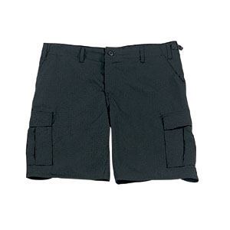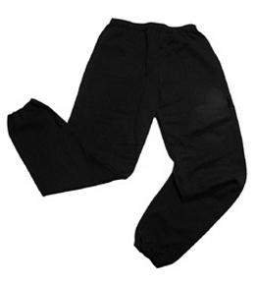Their kit should consist of a white t-shirt, dark blue or black shorts/jogging bottoms and trainers/daps.



**No jewellery is to be worn; hair needs to be tied back and head scarves must be short and tight fitting.** These are all to ensure the safety of your child.

READING

Please listen to your child read every night as this will help both their reading and writing abilities. There are a wide variety of books available on ‘Reading Eggs’ that children can choose to read at home as an additional to their reading comprehension homework. Reading comprehension is a big focus so they will need your support to help practice the skills we will teach. You can help at home by asking your child questions about their book after they have read it.

HOMEWORK

Homework is set on a Friday via ‘Reading Eggs’. They will be required to complete one reading comprehension and one spelling task per week. Homework is to be completed by the following Friday of every week. They may also be set additional homework via Purple Mash. For both ‘Reading Eggs’ and ‘Purple Mash’, passwords and usernames have been given out to the children at the start of the year. If there are any problems with access, children should inform their teacher as soon as possible.

Many Thanks,

Miss Truman, Mrs Vernon and Miss Cooper

The Year Six Team